1. 1. Ciphertext Tampering: Modify one byte of the encrypted ciphertext and attempt decryption. Observe whether the application detects the modification.
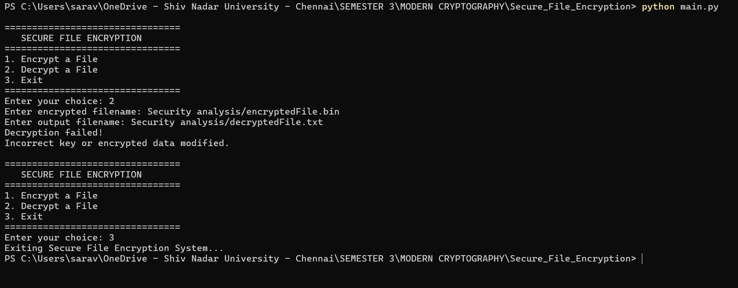

2. Experiment 2: Authentication Tag Modification
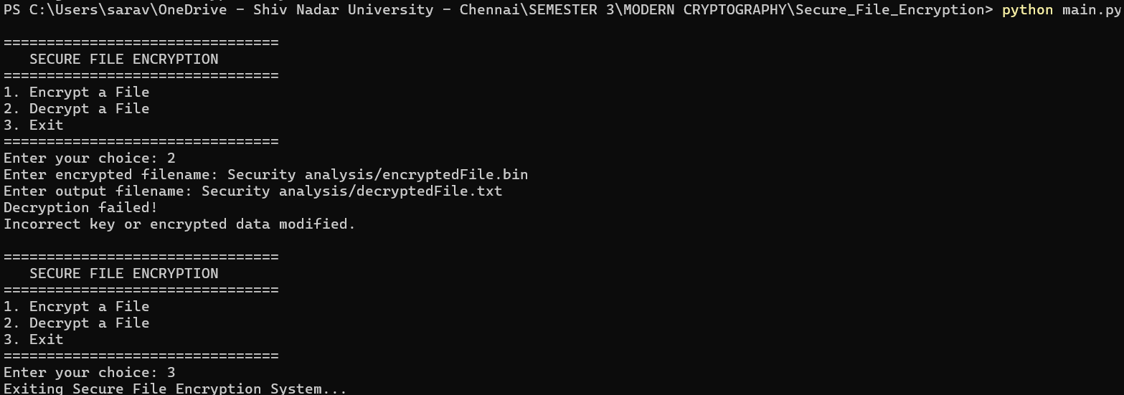

3. Wrong-Key Attack:



